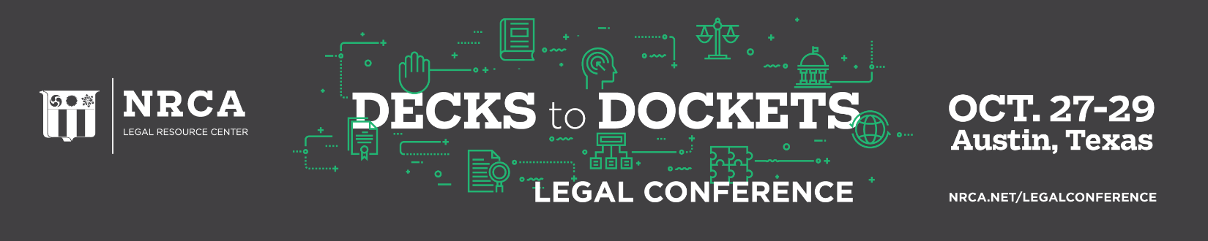

NRCA Annual Legal Conference
Roofing Issues: Decks to Dockets
Oct. 27-29, 2022
J.W. Marriott – Austin, Texas

Thursday, Oct. 27
11 a.m. – 1 p.m. Registration open
11:45 – 12:45 p.m. Boxed lunches available
12:45 – 1 p.m. Welcome – George Patterson
1 – 2:15 p.m. How to Navigate the Material Pricing in 2022 and Beyond! – Trent Cotney
2:15 – 3:30 p.m. How Long is Roofing Contractor Liable? – Stephen Phillips
3:30 – 3:45 p.m. Break
3:45 – 5 p.m. Latest Technical Issues Affecting Roofing Contractors Today - Mark Graham
6 – 7 p.m. Cocktail Reception

Friday, Oct. 28
7 – 7:30 a.m. Buffet Breakfast
7:30 – 8 a.m. NRCA Update – McKay Daniels and Kyle Thomas
8 – 9 a.m. Top 5 Immigration Issues in the Roofing Industry – Ben Briggs
9 – 9:15 a.m. Break
9:15 – 10:30 a.m. Dealing with Materials Substitutions in Contracts – Stephen Phillips
10:30 – 11:30 a.m. Technical program – Mark Graham
11:30 a.m. – 12:30 p.m. Important Insurance Issues for Roofing Contractors – Trent Cotney
Open Afternoon/Evening

Saturday, Oct. 29
7 – 7:30 a.m. Buffet Breakfast
7:30 – 8:30 a.m. Top 10 Employment Law Questions – Philip Siegel
8:30 – 9:45 a.m. Best Practices in Implementing an Effective Safety Program – Contractor Panel and Tom Shanahan (moderator)
9:45 – 10 a.m. Break
10 – 11 a.m. Negotiating an Equitable and Fair General Contractors Subcontract – Trent Cotney

11 a.m. – 12:30 p.m. Roofing and Construction Cases and Court Decisions – Stephen Phillips
12:30 p.m. Conference concludes

