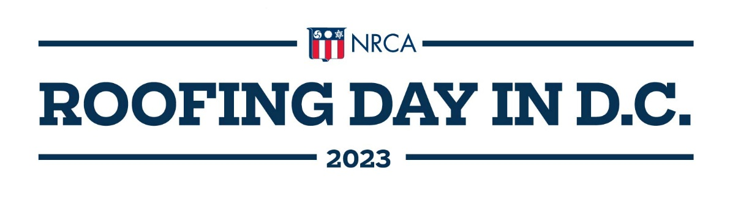
Tuesday, April 18

1 – 8 p.m. Registration open: Grand Hyatt Washington (1000 H St. NW)

3:30 – 4:15 p.m. Advocacy training and issues briefing

4:15 – 5:15 p.m. Speaker tbd
5:30 – 7 p.m. Cocktail reception sponsored by ABC Supply Inc.

Wednesday, April 19

7 a.m. – Noon Registration and advocacy station open

7:30 – 9:30 a.m. Breakfast sponsored by Beacon Building Products

8:15 a.m. Keynote Congressional Speaker sponsored by SRS Distribution
8: 45 a.m. Speaker tbd

10:00 a.m. Speaker tbd

11:00 a.m. Transportation to Capitol Hill – drop off on Senate and House sides

Noon – 5 p.m. Capitol Hill meetings, in-person

5:30 – 7:30 p.m. Wrap-up reception

Thursday, April 20 Sightseeing tours available upon request

