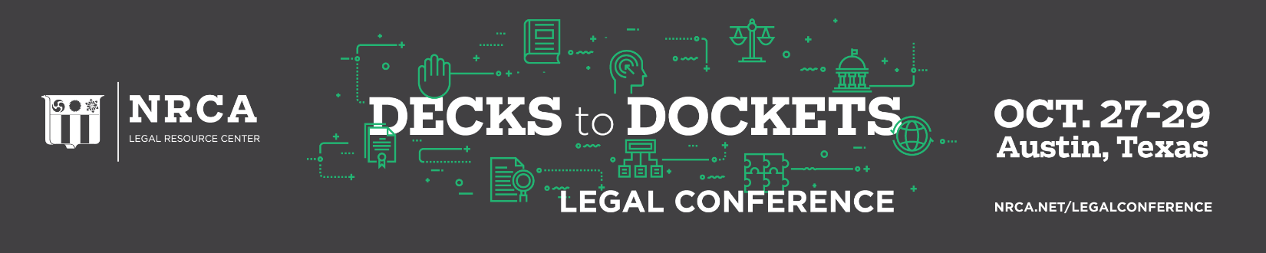

NRCA Annual Legal Conference
Roofing Issues: Decks to Dockets
J.W. Marriott – Austin, Texas
Thursday, Oct. 27
11 a.m. – 1 p.m. Registration open

11:45 – 12:45 p.m. Boxed lunches available

12:45 – 1 p.m. Welcome – George Patterson

1 – 2:15 p.m. How to Navigate the Material Pricing in 2022 and Beyond! – Trent Cotney
Issues with material availability and price increases continue to plague the industry. This presentation will discuss the latest issues surrounding the crisis including an in-depth look at the contract provisions needed for new contracts and how to navigate increased prices and lead times with existing contracts.

2:15 – 3:30 p.m. How Long is Roofing Contractor Liable? – Stephen Phillips
During this program you will learn about Statutes of Limitation and Statutes of Repose: what are they and what is the difference? and what triggers each. You will also learn about terms for discovery rule, the repair doctrine, The Nullus Tempus doctrine. Mr. Phillips will discuss court cases decided based on statutes of limitations and repose, the importance of warranties and guarantees, and other things that are important for contractors to be aware of when determining how long you are liable.

3:30 – 3:45 p.m. Break

3:45 – 5 p.m. Safety Program Incentives, Bonuses and Discipline: What to do? What should or can you do to achieve safety buy-in? - Refugio Alvarez, Joel Barnes, Erin Dennison and Tom Shanahan, moderator
In this panel program, four seasoned roofing company safety directors will share their insights into what has and hasn’t worked to achieve a safe workplace. There are no easy answers; however, there are things to consider and our panelists will share their different perspectives. This program allows time for audience members to share their ideas, too. Bring your ideas, an open mind and let’s see if we can make a difference.
6 – 7 p.m. Cocktail Reception

Friday, Oct. 28
7 – 7:30 a.m. Buffet Breakfast

7:30 – 8 a.m. NRCA Update – McKay Daniels and Kyle Thomas
During this program, you will hear a brief update about a number of NRCA’s initiatives.

8 – 9 a.m. Top 5 Immigration Issues in the Roofing Industry – Ben Briggs
Discussing the top five immigration issues within the Roofing industry in 2022, including compliance requirements, government audits and raids, and strategic options to strengthen your labor force.

9 – 9:15 a.m. Break

9:15 – 10:30 a.m. Dealing with Materials Substitutions in Contracts – Stephen Phillips
This program will help contractors navigate the materials substitutions that contractors are experiencing during this time. Mr. Phillips will talk about reasons for substitutions, how to make a substitution request Pre-Bid using AIA Document A 701- 2018 § 3.3; handling post bid material substitutions; what is the contractor liability when it comes to material substitutions; how you can propose and proceed with material substitutions and minimize liability and how to execute a change order using the AIA Document A201-2017 §3.4.2. This program will also help you protect yourself with suppliers and manufacturer’s applicator agreements

10:30 – 11:30 a.m. Managing FM Global-insured Roofing Projects – Mark Graham
Mark S. Graham, NRCA’s Vice President of Technical Services, will provide an overview of issues and pitfalls you should be aware of – and on the lookout for – when working on FM Global-insured roofing products. Topics to be addressed include the differences between FM Global as an insurance company and FM Approvals as a testing a certification agency, FM’s roofing-related requirements, FM’s prescriptive perimeter enhancements vs. performance-tested designs, FM project submissions and approval letters, and field uplift testing. Time will be allotted for questions from audience member participants.
11:30 a.m. – 12:30 p.m. Important Insurance Issues for Roofing Contractors – Trent Cotney
This seminar focuses on the top 5 insurance issues facing the roofing industry. Topics include commercial general liability coverage, subcontractor insurance issues, AOBs and first party claims, contracts and insurance, and builder's risk insurance.
Open Afternoon/Evening

Saturday, Oct. 29
7 – 7:30 a.m. Buffet Breakfast

7:30 – 8:30 a.m. Top 10 Employment Law Questions – Philip Siegel
Philip Siegel brings to this session over 25 years of experience consulting with roofing contractors over labor and employment legal issues. He relies on that experience to share with the audience the ten most common labor and employment mistakes made by roofing contractors and how to avoid those same mistakes. Among the labor and employment issues to be covered include compensable travel pay, the classification of employees/independent contractors, development of an unforeseeable employee misconduct defense in response to an OSHA citation, understanding OSHA’s multi-employer worksite doctrine, and how to address the situation of an employee suffering from an injury or medical condition that will has them out of work for an extended period of time.

8:30 – 9:45 a.m. Latest Technical Issues Affecting Roofing Contractors Today - Mark Graham
Mark S. Graham, NRCA’s Vice President of Technical Services, will provide an overview of late-breaking and developing technical issues roofing contractors should be aware of to help minimize their risks. Topics to be addressed include imported plywood and lumber, breathability of synthetic underlayment, ignition temperatures of rigid board insulation products, current problem reports and developments in the codes. Time will be allotted for questions from audience member participants.
9:45 – 10 a.m. Break

10 – 11 a.m. Negotiating an Equitable and Fair General Contractors Subcontract – Trent Cotney
This seminar will discuss the methods and techniques used to obtain roofing subcontractor favorable provisions in general contractor contracts. In addition to addressing specific contract revisions, the seminar will discuss psychological tactics used during negotiation to solicit changes in the agreement.

11 a.m. – 12:30 p.m. Roofing and Construction Cases and Court Decisions – Stephen Phillips and Leanne Prybylski
Following a tradition at the Decks to Dockets seminar, this program will cover court cases and decisions of interest and potential applicability to roofing contractors and the roofing industry. The facts and outcome of primarily appellate court decision in roofing and construction disputes will be dissected and discussed with seminar attendees who will be asked how they believe the case should have been decided.

12:30 p.m. Conference concludes

